第五十九章： Docker容器--构建企业镜像

**一、Dockerfile知识点回顾；**

**二、构建nginx镜像；**

**三、构建tomcat镜像；**

**四、构建mysql镜像；**

**五、构建lnmp镜像；**

**一、Dockerfile知识点回顾：**

**二、构建nginx镜像：**

1.安装docker，配置加速器：

2.准备centos基础镜像文件：

[root@docker ~]# docker images

REPOSITORY TAG IMAGE ID CREATED SIZE

nginx latest 06144b287844 9 days ago 109MB

centos latest 5182e96772bf 5 weeks ago 200MB

3.准备Dockerfile文件：

[root@docker ~]# mkdir /nginx

[root@docker ~]# vi /nginx/Dockerfile

FROM centos

MAINTAINER www.linuxfan.cn <docker@linuxfan.cn>

RUN yum -y install wget pcre-devel zlib-devel

RUN yum -y groupinstall "开发工具"

RUN wget http://nginx.org/download/nginx-1.12.2.tar.gz

RUN tar zxf nginx-1.12.2.tar.gz

RUN useradd nginx

WORKDIR nginx-1.12.2

RUN ./configure --prefix=/usr/local/nginx --user=nginx --group=nginx --with-http_stub_status_module

RUN make

RUN make install

EXPOSE 80

WORKDIR /root/nginx-1.12.2

ADD run.sh /run.sh

RUN chmod 755 /run.sh

CMD ["/run.sh"]

:wq

[root@docker ~]# vi /nginx/run.sh

#!/bin/bash

/usr/local/nginx/sbin/nginx

:wq

4.指定Dockfile文件进行建立镜像：

[root@docker ~]# docker build -t nginx:v1 /nginx/

Sending build context to Docker daemon 3.072kB

Step 1/14 : FROM centos

---> 5182e96772bf

Step 2/14 : MAINTAINER www.linuxfan.cn <docker@linuxfan.cn>

---> Running in 6ce95207e882

---> 34525d8d40dd

Removing intermediate container 6ce95207e882

Step 3/14 : RUN yum -y install pcre-devel zlib-devel

...

Removing intermediate container 8b2c863da8ed

Successfully built 6a4b5d40b5cf

Successfully tagged nginx:v1

[root@docker ~]# docker images |grep nginx |grep v1

nginx v1 6a4b5d40b5cf 23 seconds ago 630MB

5.启动容器：

[root@docker ~]# docker run -itd -p 8080:80 --name linuxnginx nginx:v1 /bin/bash

f25973f973b0a4488c009f279310a1785e3ac5c0da990866b31d126b96433444

[root@docker ~]# docker ps

CONTAINER ID IMAGE COMMAND CREATED STATUS PORTS NAMES

f25973f973b0 nginx:v1 "/bin/bash" 3 seconds ago Up 2 seconds 0.0.0.0:8080->80/tcp linuxnginx

[root@docker ~]# docker exec -it linuxnginx /bin/bash

[root@f25973f973b0 nginx-1.12.2]# /usr/local/nginx/sbin/nginx

[root@f25973f973b0 nginx-1.12.2]# exit

6.客户端访问测试nginx容器的服务：

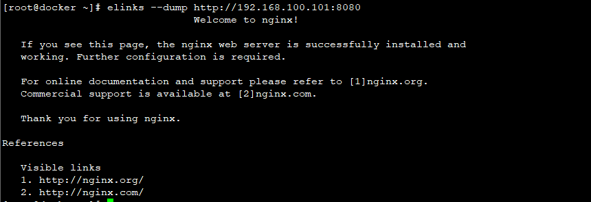

**三、构建tomcat镜像：**

1.安装docker，配置加速器：

2.准备centos基础镜像文件：

[root@docker ~]# docker images

REPOSITORY TAG IMAGE ID CREATED SIZE

nginx latest 06144b287844 9 days ago 109MB

centos latest 5182e96772bf 5 weeks ago 200MB

3.准备Dockerfile文件：

[root@docker ~]# mkdir /tomcat

[root@docker ~]# ls /tomcat/

jdk-8u171-linux-x64.tar.gz apache-tomcat-9.0.10.tar.gz

[root@docker ~]# tar zxvf /tomcat/apache-tomcat-9.0.10.tar.gz -C /tomcat/

[root@docker ~]# tar zxvf /tomcat/jdk-8u171-linux-x64.tar.gz -C /tomcat/

[root@docker ~]# vi /tomcat/Dockerfile

FROM centos

MAINTAINER www.linuxfan.cn <docker@linuxfan.cn>

ADD jdk1.8.0_171 /usr/local/java

ADD apache-tomcat-9.0.10 /usr/local/tomcat

ENV JAVA_HOME /usr/local/java

ENV JAVA_BIN /usr/local/java/bin

ENV JRE_HOME /usr/local/java/jre

ENV PATH $PATH:/usr/local/java/bin:/usr/local/java/jre/bin

ENV CLASSPATH /usr/local/java/jre/bin:/usr/local/java/lib:/usr/local/java/jre/lib/charsets.jar

EXPOSE 8080

:wq

4.指定Dockfile文件进行建立镜像：

[root@docker ~]# docker build -t tomcat:v1 /tomcat/

Sending build context to Docker daemon 604MB

Step 1/10 : FROM centos

---> 5182e96772bf

Step 2/10 : MAINTAINER www.linuxfan.cn <docker@linuxfan.cn>

---> Using cache

---> 34525d8d40dd

Step 3/10 : ADD jdk1.8.0_171 /usr/local/java

---> e65e5f5a4b29

...

Removing intermediate container 789ffa817375

Successfully built ffe4fbb2dd52

Successfully tagged tomcat:v1

[root@docker ~]# docker images |grep tomcat |grep v1

tomcat v1 ffe4fbb2dd52 6 minutes ago 601MB

5.启动容器：

[root@docker ~]# docker run -itd -p 8081:8080 --name linuxtomcat tomcat:v1 /bin/bash

ccd199336e58c10790bd6d537d302441ad61bbed1c7a97247e5be8fdaff8957a

[root@docker ~]# docker ps |grep tomcat

ccd199336e58 tomcat:v1 "/bin/bash" 6 seconds ago Up 5 seconds 0.0.0.0:8081->8080/tcp linuxtomcat

[root@docker ~]# docker exec -it linuxtomcat /bin/bash

[root@ccd199336e58 /]# /usr/local/tomcat/bin/startup.sh

Tomcat started.

[root@ccd199336e58 /]# exit

exit

[root@docker ~]# netstat -utpln |grep 8081

tcp 0 0 0.0.0.0:8081 0.0.0.0:* LISTEN 25292/docker-proxy

6.客户端访问测试nginx容器的服务：

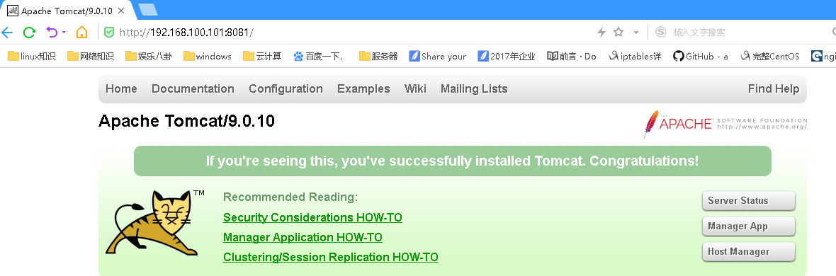

**四、构建mysql镜像：**

1.安装docker，配置加速器：

2.准备centos基础镜像文件：

[root@docker ~]# docker images

REPOSITORY TAG IMAGE ID CREATED SIZE

nginx latest 06144b287844 9 days ago 109MB

centos latest 5182e96772bf 5 weeks ago 200MB

3.准备Dockerfile文件：

[root@docker ~]# mkdir /mysql

[root@docker ~]# ls /mysql/

boost_1_59_0.tar.gz mysql-5.7.12.tar.gz

[root@docker ~]# vi /mysql/Dockerfile

FROM centos

MAINTAINER www.linuxfan.cn <docker@linuxfan.cn>

RUN yum -y groupinstall "开发工具"

RUN yum -y install zlib zlib-devel gcc gcc-c++ ncurses ncurses-devel bison libgcrypt perl cmake

RUN groupadd mysql

RUN useradd -r -g mysql mysql

ADD boost_1_59_0.tar.gz /usr/local/

ADD mysql-5.7.12.tar.gz /tmp

WORKDIR /tmp/mysql-5.7.12

RUN cmake . -DCMAKE_INSTALL_PREFIX=/usr/local/mysql -DMYSQL_DATADIR=/usr/local/mysql/data -DDEFAULT_CHARSET=utf8 -DDEFAULT_COLLATION=utf8_general_ci -DMYSQL_TCP_PORT=3306 -DMYSQL_USER=mysql -DWITH_MYISAM_STORAGE_ENGINE=1 -DWITH_INNOBASE_STORAGE_ENGINE=1 -DWITH_ARCHIVE_STORAGE_ENGINE=1 -DWITH_BLACKHOLE_STORAGE_ENGINE=1 -DWITH_MEMORY_STORAGE_ENGINE=1 -DENABLE_DOWNLOADS=1 -DDOWNLOAD_BOOST=1 -DWITH_BOOST=/usr/local/boost_1_59_0 -DSYSCONFDIR=/etc

RUN make

RUN make install

RUN chown -R mysql:mysql /usr/local/mysql

RUN rm -rf /etc/my.cnf

RUN cp /tmp/mysql-5.7.12/support-files/my-default.cnf /etc/my.cnf

RUN cp /tmp/mysql-5.7.12/support-files/mysql.server /etc/init.d/

RUN chmod +x /etc/init.d/mysql.server

ADD mysqld.service /usr/lib/systemd/system/

ENV PATH $PATH:/usr/local/mysql/bin/

RUN mysqld --initialize-insecure --user=mysql --basedir=/usr/local/mysql --datadir=/usr/local/mysql/data

RUN rm -rf /etc/my.cnf

ADD my.cnf /etc/

RUN mkdir /usr/local/mysql/logs

RUN chown mysql:mysql /usr/local/mysql/logs/

EXPOSE 3306

:wq

[root@docker ~]# vi /mysql/mysqld.service

[Unit]

Description=mysqldapi

After=network.target

[Service]

Type=forking

PIDFile=/usr/local/mysql/logs/mysqld.pid

ExecStart=/etc/init.d/mysql.server start

ExecReload=/etc/init.d/mysql.server restart

ExecStop=/etc/init.d/mysql.server stop

PrivateTmp=Flase

[Install]

WantedBy=multi-user.target

:wq

[root@docker ~]# vi /mysql/my.cnf

[mysqld]

basedir = /usr/local/mysql

datadir = /usr/local/mysql/data

port = 3306

sql_mode=NO_ENGINE_SUBSTITUTION,STRICT_TRANS_TABLES

character_set_server=utf8

init_connect='SET NAMES utf8'

log-error=/usr/local/mysql/logs/mysqld.log

pid-file=/usr/local/mysql/logs/mysqld.pid

skip-name-resolve

:wq

[root@docker ~]# ls /mysql/

boost_1_59_0.tar.gz Dockerfile my.cnf mysql-5.7.12.tar.gz mysqld.service

4.指定Dockfile文件进行建立镜像：

[root@docker ~]# docker build -t mysql:v1 /mysql/

Sending build context to Docker daemon 553.1MB

Step 1/27 : FROM centos

---> 5182e96772bf

Step 2/27 : MAINTAINER www.linuxfan.cn <docker@linuxfan.cn>

---> Using cache

---> 34525d8d40dd

Step 3/27 : RUN yum -y install wget

---> Running in 90c6e3b0938a

Loaded plugins: fastestmirror, ovl

...

Step 25/25 : EXPOSE 3306

---> Running in 6ccf4a820227

---> 4f2b56cbe72f

Removing intermediate container 6ccf4a820227

Successfully built 4f2b56cbe72f

Successfully tagged mysql:v1

[root@docker ~]# docker images |grep mysql|grep v1

mysql v1 4f2b56cbe72f 50 seconds ago 10.2GB

5.启动容器：

[root@docker ~]# docker run -itd -p 3306:3306 --name linuxmysql mysql:v1 /usr/sbin/init

78866661c6b891200f6a9a67650a9371d9fa9d454f8dcd37f8ef9ceda8dd9460

[root@docker ~]# docker ps |grep mysql

78866661c6b8 mysql:v1 "/usr/sbin/init" 9 seconds ago Up 8 seconds 0.0.0.0:3306->3306/tcp linuxmysql

[root@docker ~]# docker exec -it linuxmysql /bin/bash

[root@78866661c6b8 mysql-5.7.12]# yum -y install net-tools

[root@78866661c6b8 mysql-5.7.12]# /etc/init.d/mysql.server start

Starting MySQL. SUCCESS!

[root@78866661c6b8 mysql-5.7.12]# mysql

mysql> alter user 'root'@'localhost' identified by '123123';

Query OK, 0 rows affected (0.00 sec)

mysql> grant all on *.* to 'root'@'192.168.100.100' identified by '123123';

Query OK, 0 rows affected, 1 warning (0.00 sec)

mysql> flush privileges;

Query OK, 0 rows affected (0.00 sec)

mysql> exit

Bye

[root@78866661c6b8 mysql-5.7.12]# netstat -utpln

Active Internet connections (only servers)

Proto Recv-Q Send-Q Local Address Foreign Address State PID/Program name

tcp 0 0 0.0.0.0:3306 0.0.0.0:* LISTEN -

[root@78866661c6b8 mysql-5.7.12]# exit

6.客户端访问测试mysql容器的服务：



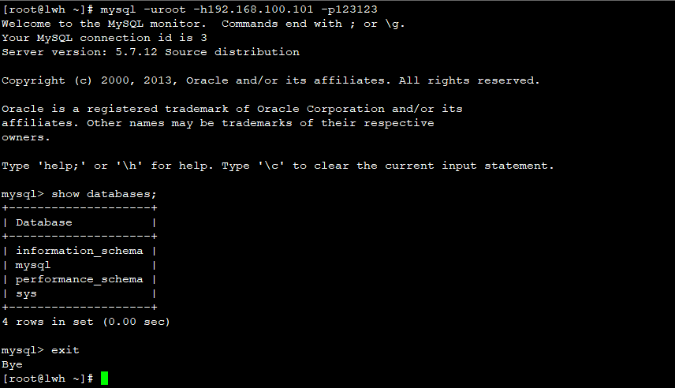

**五、构建lnmp镜像：**